Chapter 2 p.19

Top human-operated ransomware variants that achieved breaches

Pie chart showing percentages of Top human-operated ransomware variants that achieved breaches. It shows A. Lockbit 3.0: 16%, B. BlackBasta: 14%, C. Blackcat: 14%, D. Royal: 12%, and E. BlackByte Hive, Play Akira, BitLocker Cartel, Cuba Dagoned Gazprom Lorenz Prestige Ragnarlocker Rorschach Vice Society Dharma: 44%.

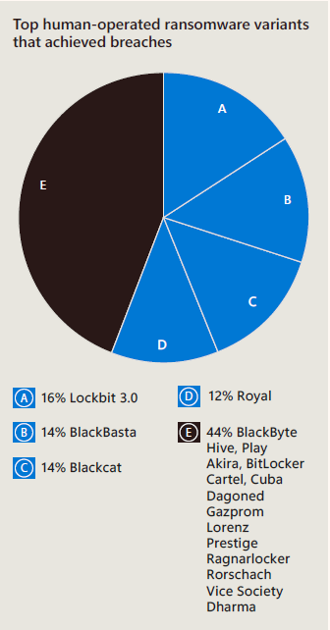

Source: Microsoft Incident Response